Movement testing:

To complete the move test, we randomly selected a number of coordinates. And record the accuracy of the robot to the destination coordinates. During the test, the robot walked to the correct coordinates exactly as instructed. As shown in the figure below, I extracted two points from it as examples.

The coordinate of this point is <-2.55, 0.144>, and the robot reached the exact position.

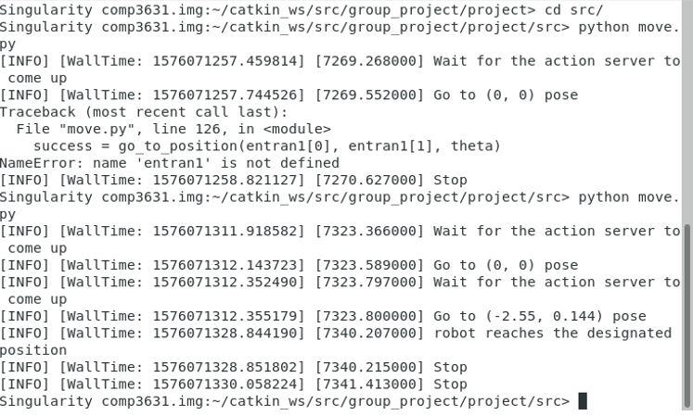

Run the move command, the robot first reaches the coordinates <0, 0>, then come to <-2.55, 0.144>, and finally the terminal reports that robot reaches the designated position.

The coordinate of this point is <-2.83, -1.51>, and the robot reached the exact position.

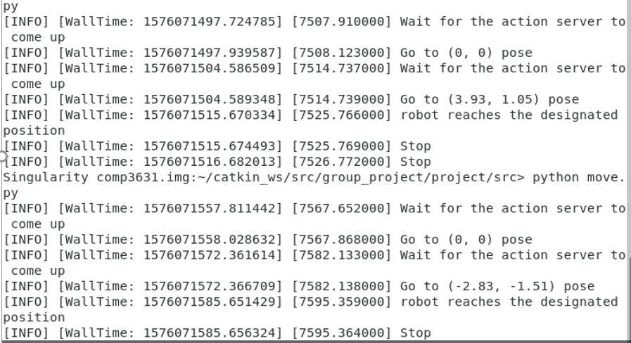

Run the move command, the robot first reaches the coordinates <0, 0>, then come to <-2.83, -1.51>, and finally the terminal reports that robot reaches the designated position.